- tytuł artykułu,
- streszczenie,
- ważne dla rozumienia tematu artykułu rysunki, tabele lub wykresy,
- podsumowanie lub wnioski.
Treści należy podać w języku polskim i angielskim

Artykuł 1
Jasiulewicz-Kaczmarek, M., Antosz, K., Wyczółkowski, R., Mazurkiewicz, D., Sun, B., Qian, C., & Ren, Y. (2021). Application of MICMAC, Fuzzy AHP, and Fuzzy TOPSIS for evaluation of the maintenance factors affecting sustainable manufacturing. Energies, 14(5), 1436.

Abstrakt graficzny
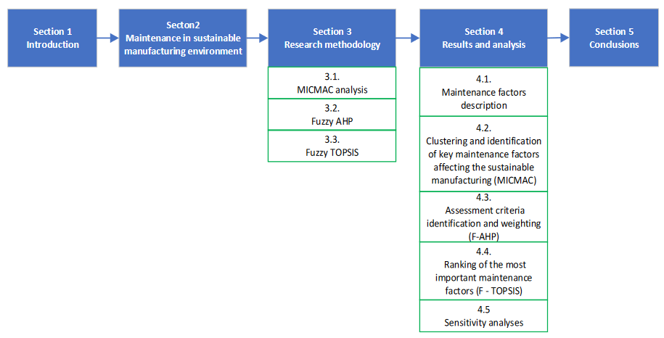

Conclusion
In this study, an integrated approach (MICAMC, F-AHP, and F-TOPSIS) was used to analyze the maintenance factors influencing the implementation of sustainable manufacturing challenges from a tactical perspective, and to rank them taking into account the specificity of an operational context of an enterprise. Ten maintenance factors for achieving sustainable manufacturing challenges have been described based on a literature analysis and discussion with experts from the industry. After that, MICMAC analysis was used to identify the key maintenance factors. Based on the influence and dependence value, the factors involved in the study were classified into four clusters: I—autonomous factors, II—dependent factors, III—linkage factors, and IV—independent factors.
Factors from the clusters III and IV were considered key maintenance factors affecting sustainable manufacturing and were taken as an inputs for F-TOPSIS analysis. Then, the assessment criteria of maintenance factors were identified, and their relative weights were determined by fuzzy AHP. Finally, the results of MICMAN and fuzzy AHP analyses were used as an input to rank the maintenance factors by the fuzzy TOPSIS method. As a result of this method, the most important maintenance factors that have an impact on sustainable manufacturing processes were identified. The analysis showed that technical factors (“The usage of M&O data collection and processing systems”, “Implementation of preventive and prognostic service strategies”, and “Modernization of machines and devices”) are rated as the most important and influential for sustainable manufacturing.

Artykuł 2
Antosz, K., Jasiulewicz-Kaczmarek, M., Paśko, Ł., Zhang, C., & Wang, S. (2021). Application of machine learning and rough set theory in lean maintenance decision support system development. Eksploatacja i Niezawodność - c – Maintenance and Reliability, 23(4): 695–7.
Streszczenie
Lean maintenance concept is crucial to increase the reliability and availability of maintenance equipment in the manufacturing companies. Due the elimination of losses in maintenance processes this concept reduce the number of unplanned downtime and unexpected failures, simultaneously influence a company’s operational and economic performance. Despite the widespread use of lean maintenance, there is no structured approach to support the choice of methods and tools used for the maintenance function improvement. Therefore, in this paper by using machine learning methods and rough set theory a new approach was proposed. This approach supports the decision makers in the selection of methods and tools for the effective implementation of Lean Maintenance.
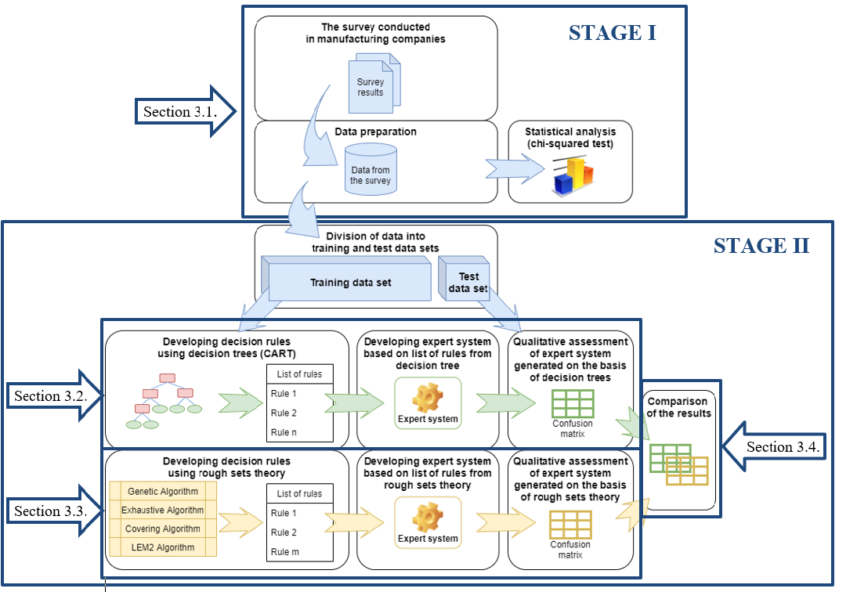
Conclusions
Many companies use LM mainly to eliminate production losses. These companies not only increase their productivity, but also strengthen their position on the market. It turns out that companies have started to recognize the importance of maintenance, so they have started implementing LMn. In this paper the problem of LMn implementation assessment was analyzed. Firstly the data from the manufacturing companies were collected and preliminary analyzed. The chi-square test for identification the factor affecting for LMn were used. Then, the machine learning method to developed the classification models was proposed. These models by using DT (CART) and RST (four different algorithms: LEM2, Exh.Alg. Cov.Alg and GenAlg). were developed. To develop these models, data obtained from companies, that implemented LMn were used. In the first stage of the survey, information from companies was collected on: used maintenance strategies, implemented LMn methods and tools, and the results of the implementation. To assess the benefits of the LMn implementation the indicator NUD was analyzed.
The obtained results indicate, that both for the classifiers obtained, RST and DT have a high prediction ability. However, the accuracy of the prediction depends from the analysed class. The predictive model generated by DT show the better prediction ability in the analyzed class 30-50%. However, the situation in RST is slightly different. The same high prediction ability was demonstrated by the model generated with the use of the genetic algorithm. For the two most frequently occurring classes, this model has the same high predictive ability. However, better accuracy for the class of 30–50% were achieved for RST for LEM2 algorithm. It should be noted that this algorithm generates the smallest number of decision rules. This shows that a large number of decision rules is not required to obtain good ability of prediction models. For the 10-30% class, the best prediction ability was obtained for the model with the use of the coverage algorithm. The worst prediction ability for the most frequently occurring classes was achieved by models generated with the use of the coverage algorithm.

